**REPORT- PHASE 1**

**AI-Powered Peer Tutoring & Study Planne**

**Planning & Proposal  
•** Team Lead**: Mani Manvith Devineni  
•** AI Researcher**: Dedeepya Chaalika Chukka   
•** Documentation Lead**: Shravan Kumar Goud Earukala  
•** UX Designer**: Vishnu Darimireddy  
•** Scrum Reporter**: Sriman Goud Emagouda**

**1. Introduction**

This report provides a detailed analysis of the provided Entity-Relationship (ER) Diagram and database schema for an online tutoring platform. The ER diagram serves as a blueprint for the relational database, visually representing the data entities, their attributes, and the relationships between them. The design aims to create a normalized, efficient, and scalable database to manage user information, subject specializations, study plans, and tutoring-related tasks.

**2. Entity Descriptions**

The database schema consists of the following ten entities (tables), each with a distinct purpose and set of attributes:

* **USER**
  + **Purpose:** The central table for all users of the platform, including students and tutors.
  + **Attributes:**
    - user_id: int, Primary Key (PK) – A unique identifier for each user.
    - email: string – The user's email address.
    - password_hash: string – The hashed password for security.
    - role: string – The user's role on the platform (e.g., 'student', 'tutor').
    - created_at: datetime – Timestamp of account creation.
    - verified: boolean – Status indicating if the user's account has been verified.
* **PROFILE**
  + **Purpose:** Stores public-facing profile information for a user.
  + **Attributes:**
    - profile_id: int, PK – Unique identifier for a profile record.
    - user_id: int, Foreign Key (FK) – Links to the USER table.
    - display_name: string – The user's preferred display name.
    - bio: text – A short biography of the user.
    - rating: float – The user's overall rating.
* **SUBJECTS**
  + **Purpose:** A catalog of all academic subjects available on the platform.
  + **Attributes:**
    - subject_id: int, PK – Unique identifier for each subject.
    - name: string – The full name of the subject (e.g., 'Mathematics').
    - code: string – A short code for the subject (e.g., 'MATH101').
* **TUTORSUBJECT**
  + **Purpose:** This is a junction table that resolves the many-to-many relationship between USER (tutors) and SUBJECTS. It specifies which subjects a particular tutor teaches.
  + **Attributes:**
    - tutorsubject_id: int, PK – Unique identifier for this relationship record.
    - user_id: int, FK – Links to the USER table (for the tutor).
    - subject_id: int, FK – Links to the SUBJECTS table.
    - hourly_rate: date – The hourly rate charged by the tutor for this specific subject.
    - specialties: text – Specific skills or specializations within the subject.
* **AVAILABILITY**
  + **Purpose:** Tracks a user's (likely a tutor's) available time slots.
  + **Attributes:**
    - availability_id: int, PK – Unique identifier for each availability slot.
    - user_id: int, FK – Links to the USER table.
    - start_time: date – The start date and time of the availability slot.
    - end_date: date – The end date and time of the availability slot.
    - completion_pct: float – Percentage completion, possibly for a task tied to this availability.
* **TASK**
  + **Purpose:** Records reviews or tasks completed on the platform.
  + **Attributes:**
    - review_id: int, PK – Unique identifier for the review/task.
    - session_id: int, FK – Links to a session record (assuming a SESSION table would exist).
    - author_id: int, FK – Links to the USER table (the user who wrote the review).
    - target_id: int, FK – Links to the USER table (the user being reviewed).
    - rating: int – A numerical rating.
    - comment: text – The text of the review.
    - datetime: datetime – The timestamp of the review.
* **STUDYPLAN**
  + **Purpose:** Stores personalized study plans created by or for a user.
  + **Attributes:**
    - plan_id: int, PK – Unique identifier for a study plan.
    - user_id: int, FK – Links to the USER table.
    - title: string – The title of the study plan.
    - due_date: date – The due date for the plan.
    - completed: boolean – Status indicating if the plan is completed.
    - progress_pct: float – The percentage progress of the plan.
* **AIREQUEST**
  + **Purpose:** Logs requests made to an AI assistant feature.
  + **Attributes:**
    - airequest_id: int, PK – Unique identifier for the AI request.
    - user_id: int, FK – Links to the USER table

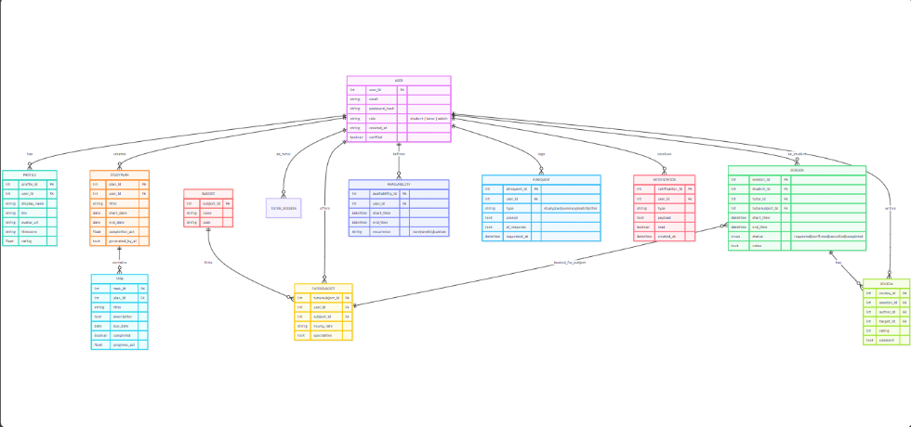

**3. Relationship Analysis**

The ER diagram illustrates the following key relationships between the entities:

* **One-to-One Relationship:**
  + **USER and PROFILE:** A user can have at most one profile, and a profile belongs to exactly one user. This optional relationship is indicated by the 0 near the PROFILE entity.
* **One-to-Many Relationships:**
  + **USER to STUDYPLAN:** A user can have many study plans, but each study plan belongs to only one user.
  + **USER to AVAILABILITY:** A user can have multiple availability slots, but each slot is for a single user.
  + **USER to AIREQUEST:** A user can make multiple AI requests, but each request is tied to a single user.
* **Many-to-Many Relationship (Resolved):**
  + **USER and SUBJECTS:** This relationship is resolved by the TUTORSUBJECT junction table. A single USER (as a tutor) can be associated with many SUBJECTS, and a single SUBJECT can be taught by many USERS. The TUTORSUBJECT table links them and holds additional data (hourly_rate, specialties) specific to that unique pairing.
* **Self-Referencing Relationship:**
  + 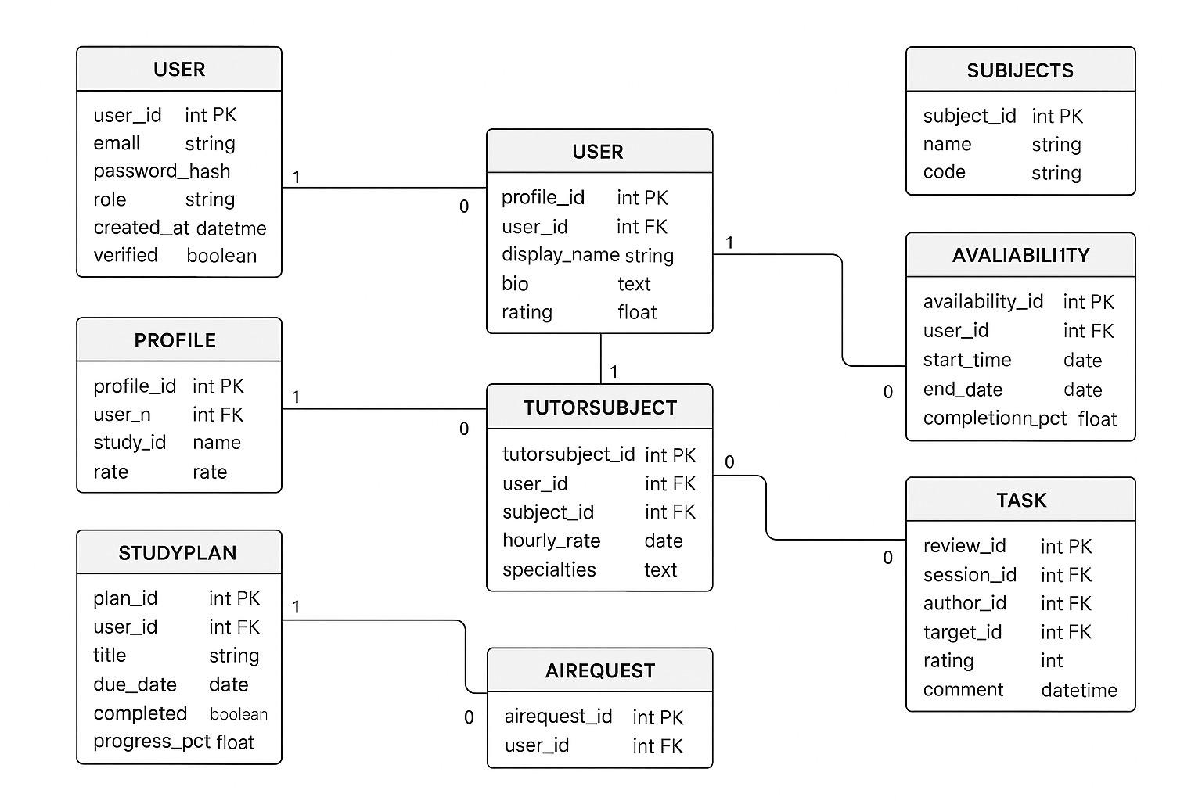**TASK to USER:** The TASK table uses two foreign keys (author_id and target_id) that both reference the USER table. This allows the database to track who created a task (e.g., a review) and who the task is about (the recipient of the review), all within a single table.

**4.Basic Outline**

**Homepage**

**5. Conclusion**

The ER diagram and schema represent a well-structured and normalized database design for the tutoring platform. The use of separate entities for distinct data types, such as users, subjects, and study plans, prevents data redundancy. The correct resolution of the many-to-many relationship between users and subjects using a junction table demonstrates a sound understanding of relational database principles. The design is robust and can be extended in the future to include additional functionalities, such as a dedicated SESSION table to manage the lifecycle of tutoring sessions.